**Database Development and Class Registration**

Xenia Reid

The University of Arizona Global Campus

CST499: Capstone for Computer Software Technology

Professor Joseph Rangitsch

July 29, 2025

**Database Development and Class Registration**

As part of this project, I worked through several key stages to build and connect the system functionality. Here’s a breakdown of the main steps I took and what I learned from the process:

1. Setting Up User Authentication

* I started by creating a users table and building both registration and login pages.
* To keep things secure, I used password hashing and validation.
* I implemented PHP sessions so users could stay logged in as they navigated the site.

1. Connecting Frontend and Backend

* I linked HTML forms to PHP scripts that handle the backend processing.
* I set up the database connection and learned how to handle common connection errors.
* I also used prepared statements to prevent SQL injection and improve security.

1. Adding Course Registration Features

* I added new tables for storing course and registration information.
* I built pages that display available courses and allow users to register or drop them.
* I made sure the database updated correctly whenever changes were made to a user’s course list.

1. Debugging and Troubleshooting

* I ran into some issues like blank pages, which I resolved by turning on error reporting.
* I identified and fixed missing code that was causing fatal errors.
* I also double-checked session handling and SQL queries to make sure everything was working as expected.
* I added detailed error messages for easier debugging.

1. Improving User Experience

* I included success and error messages to provide feedback to users after certain actions.
* I implemented a logout feature that clears the session properly.
* I kept the design clean and simple by using basic HTML tables and forms for usability.

**Overall Reflection**

Overall, this project really helped me understand and apply important web development best practices. I gained a stronger appreciation for things like proper error handling, secure session and database management, step-by-step debugging, and keeping the frontend and backend logic clearly separated. It was a valuable hands-on experience that gave me a clearer picture of how to build a secure and functional user/course management system from the ground up.

Screenshots of the database and the tables created:

Users:  
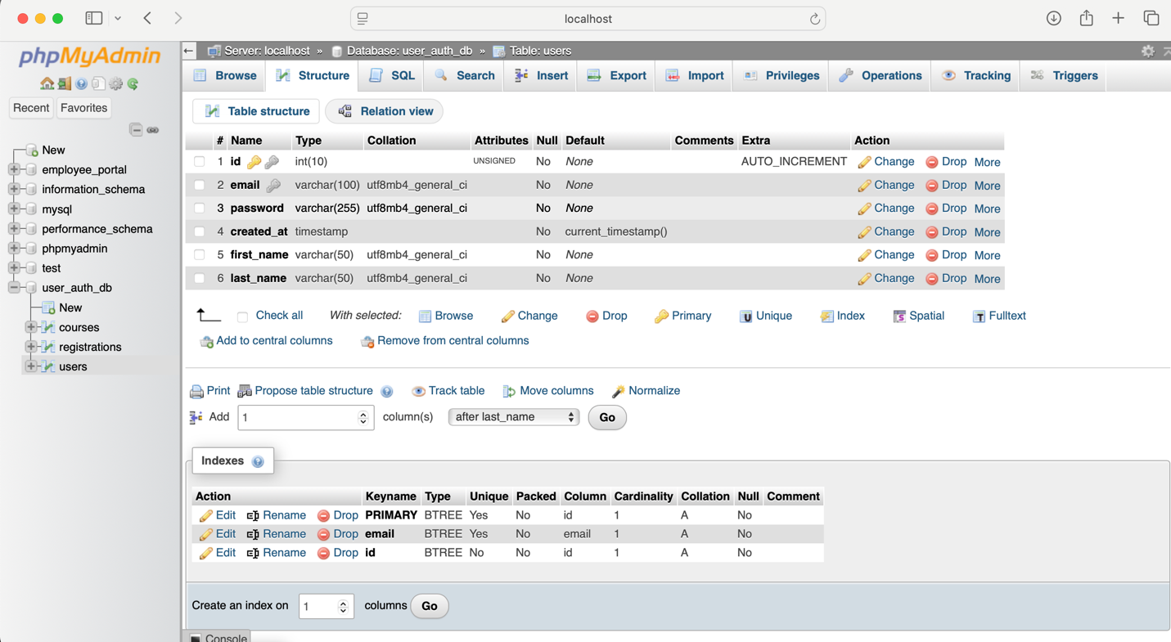

Registration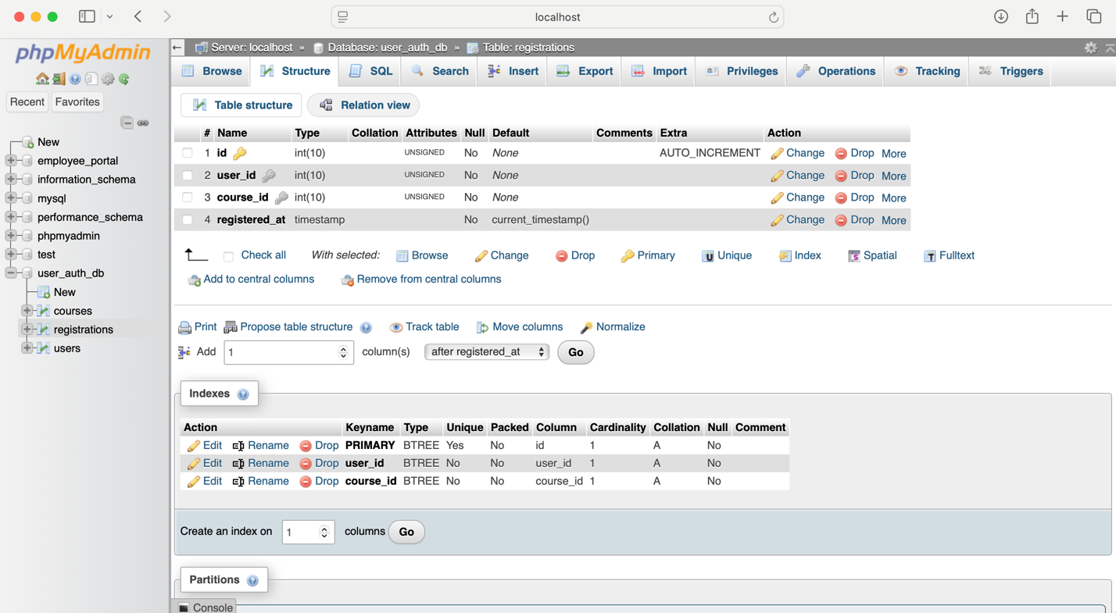

Courses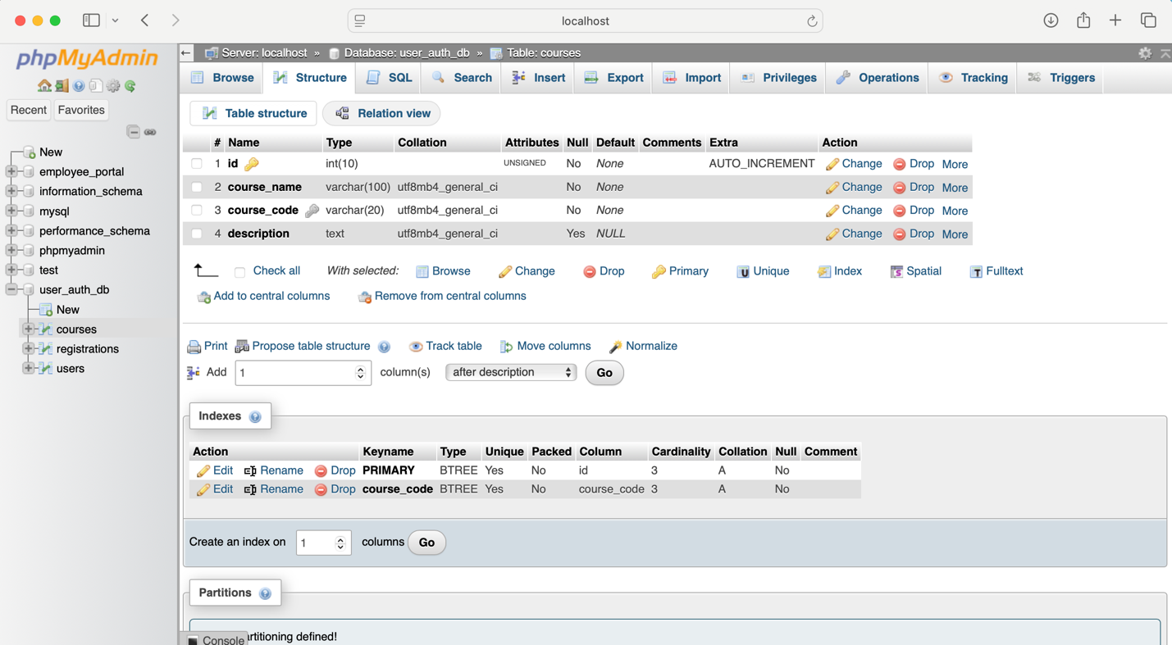 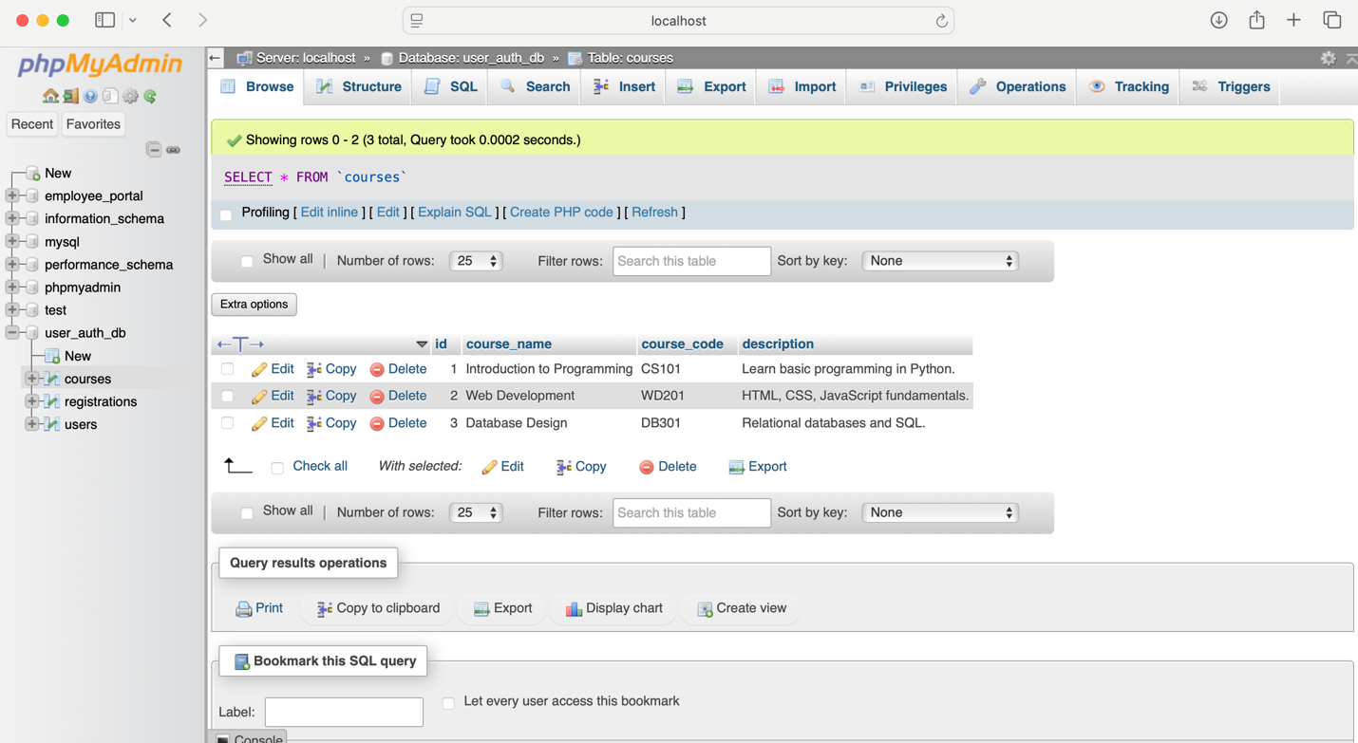

Screenshots of the different pages that you created:  
Welcome Page:

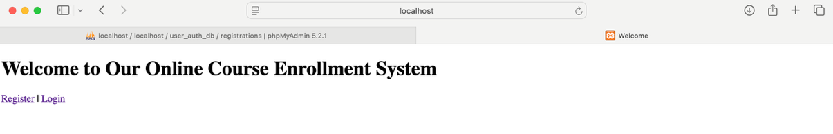

User Registration:

Successful Registration:  
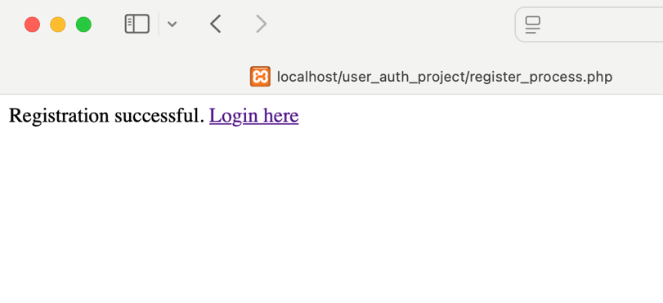

Unsuccessful Registration:

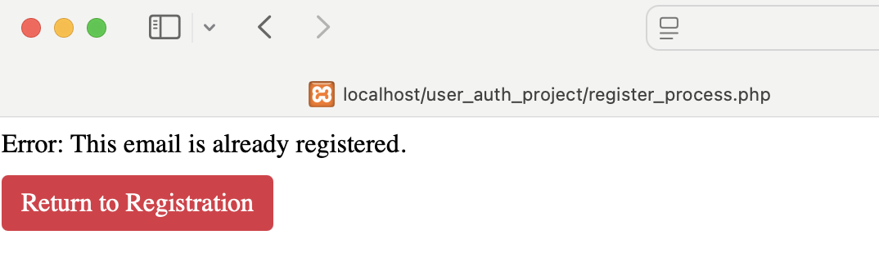

User Login

Login error when no email found:  
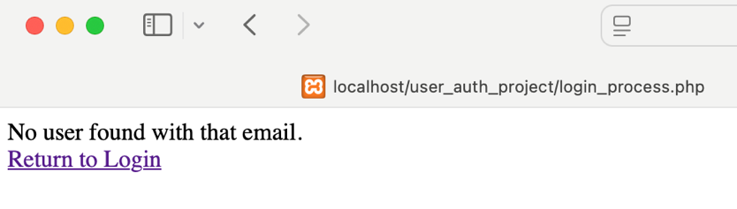

Login error when wrong password is used:  
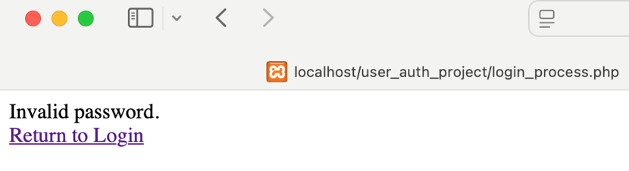

User Registration Page:  
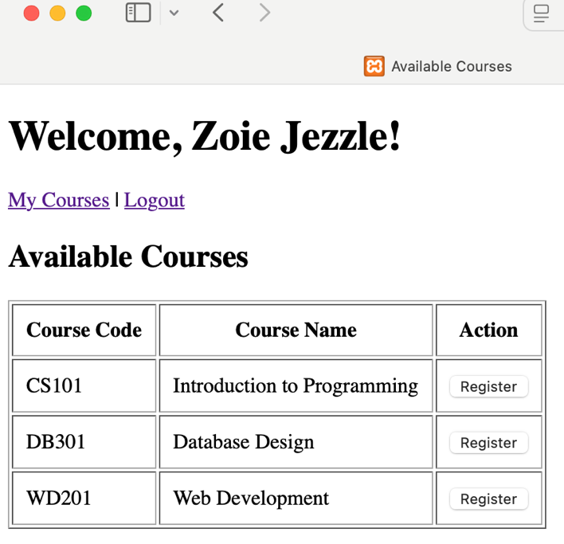

Registration Successful:  
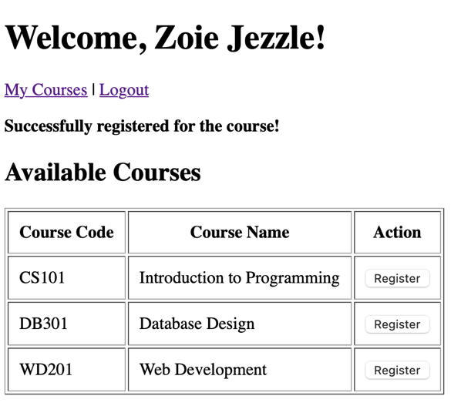

My Courses:

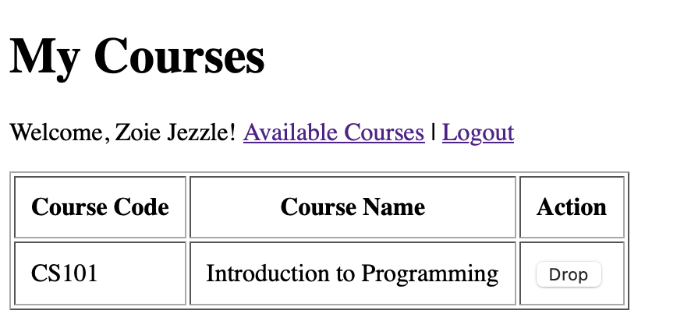

Drop Courses with a confirmation:

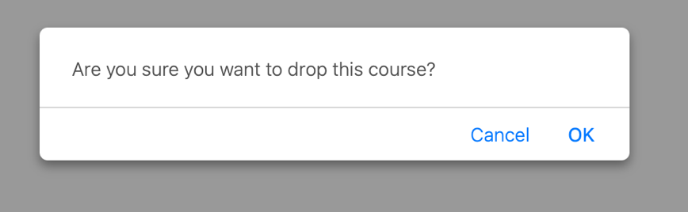



Logout:  
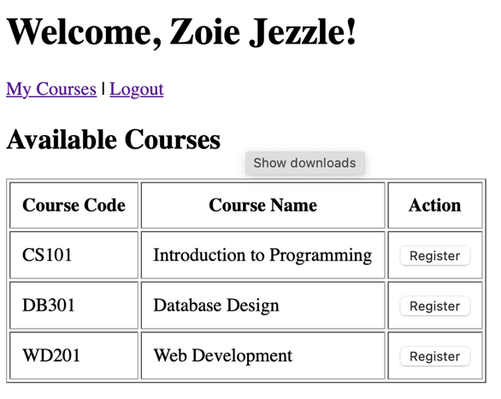 

Register.php:

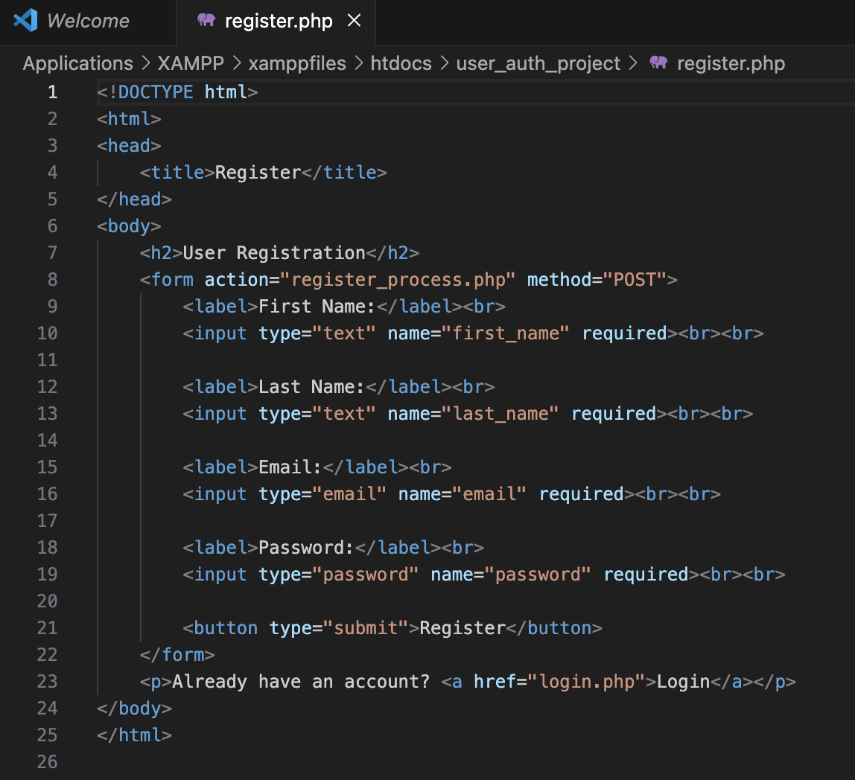

Index.php

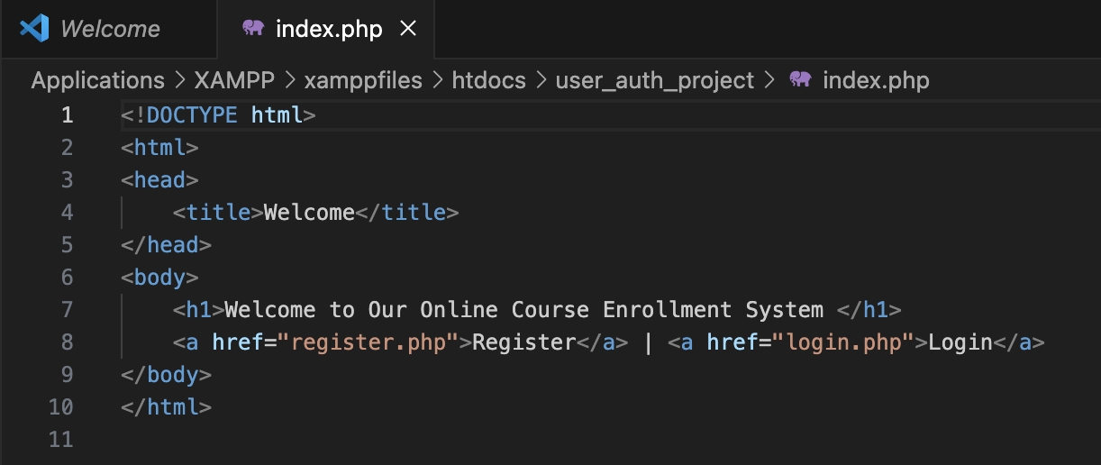

Db.php

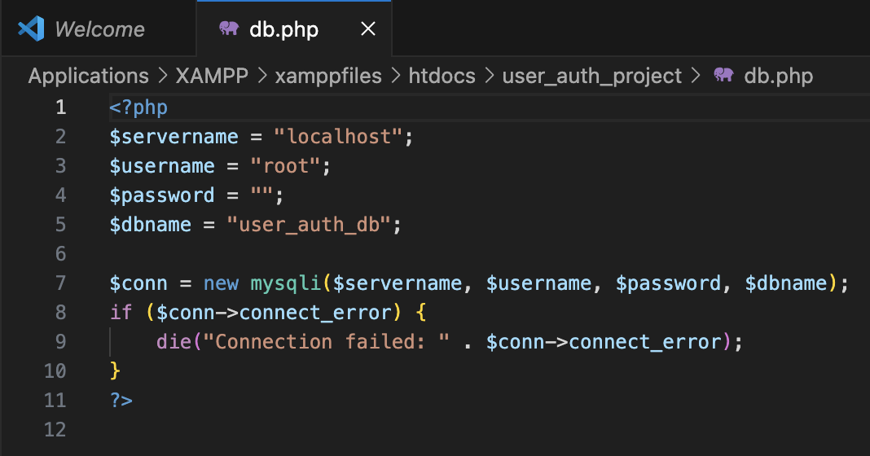

Login.php

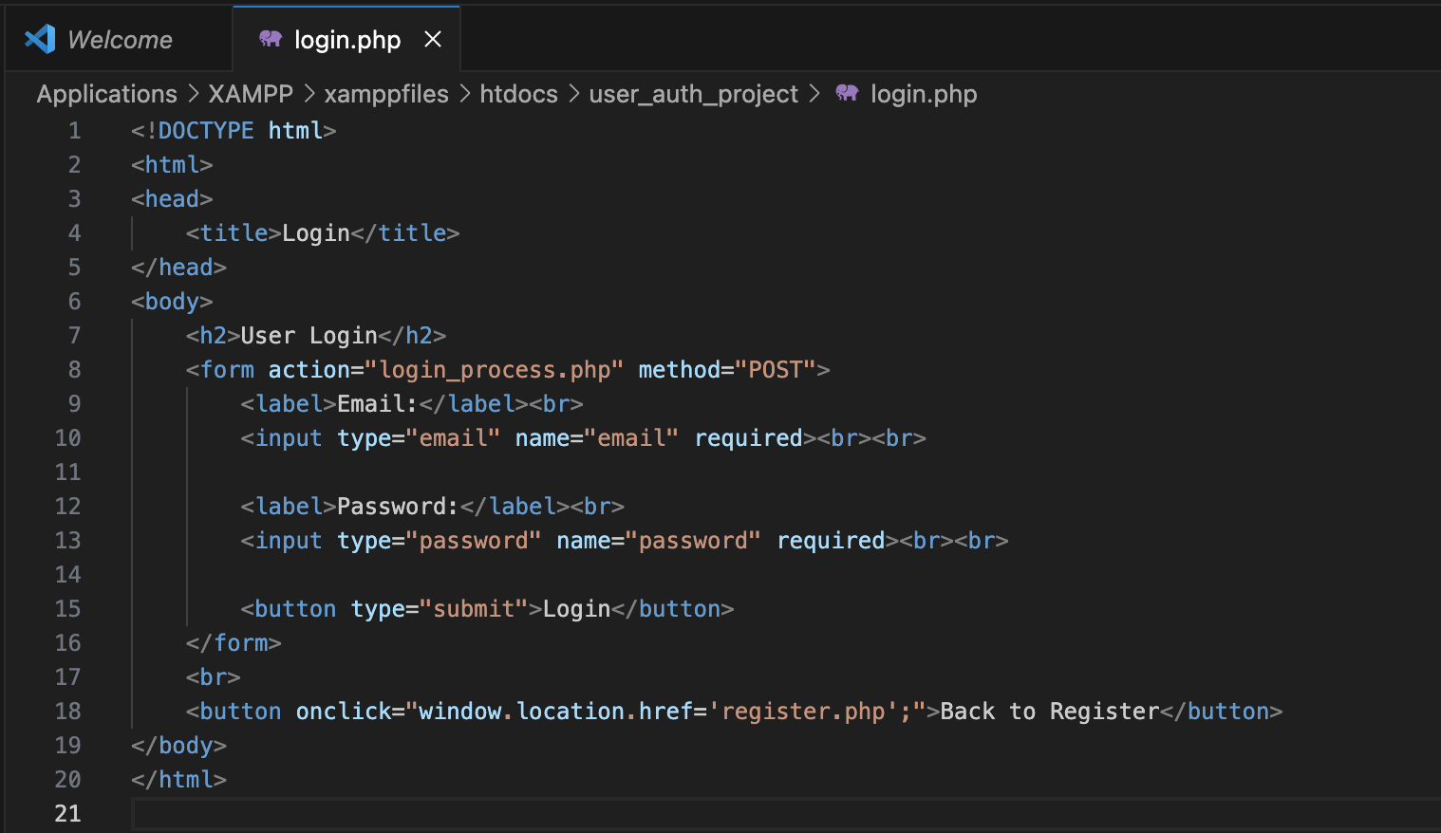

Register_process.php

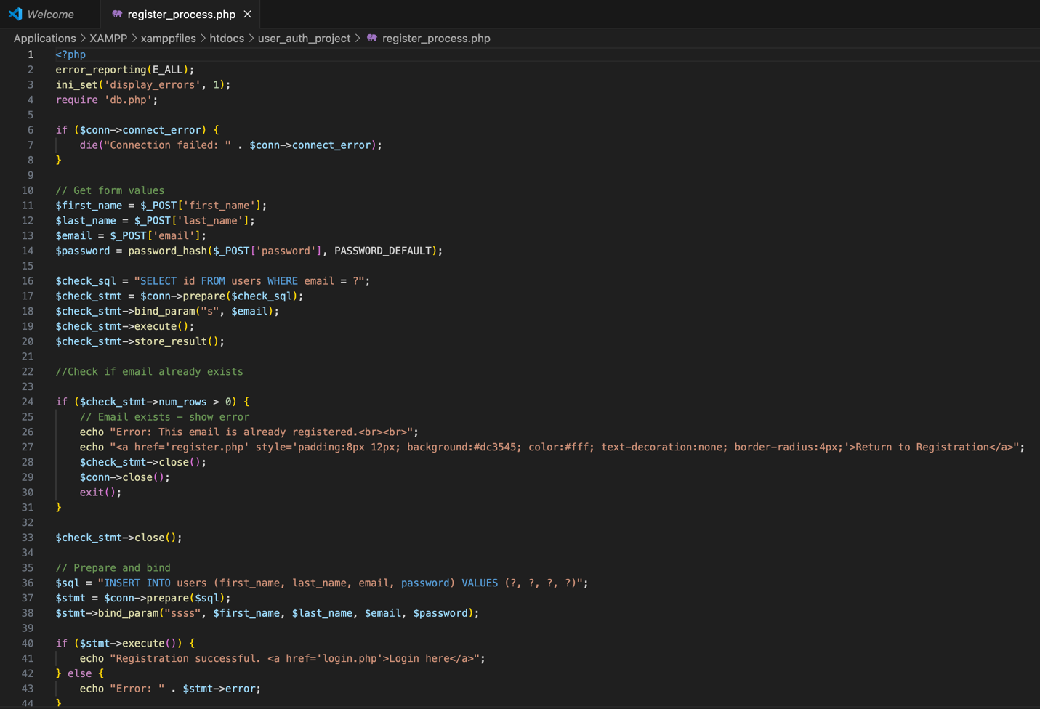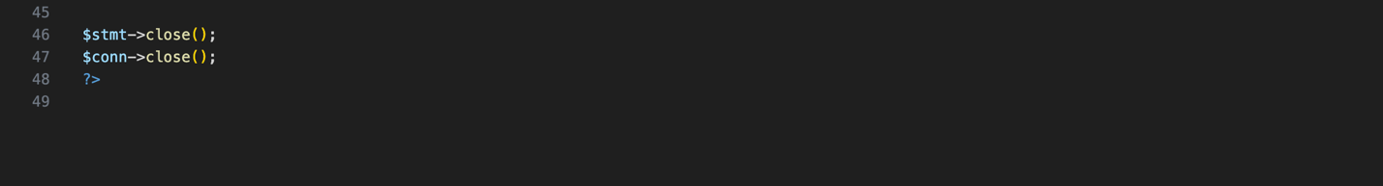

Login.php

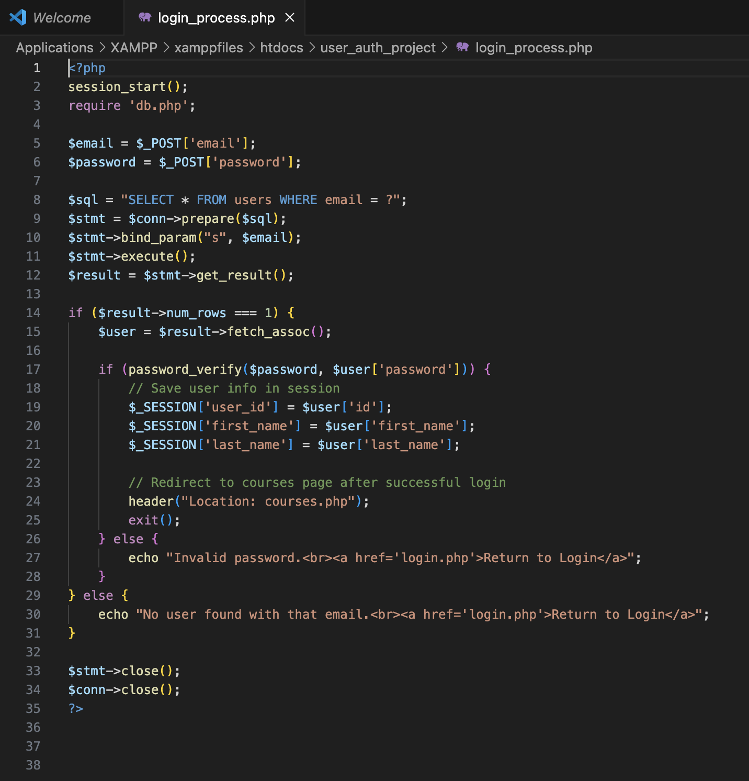

Courses.php: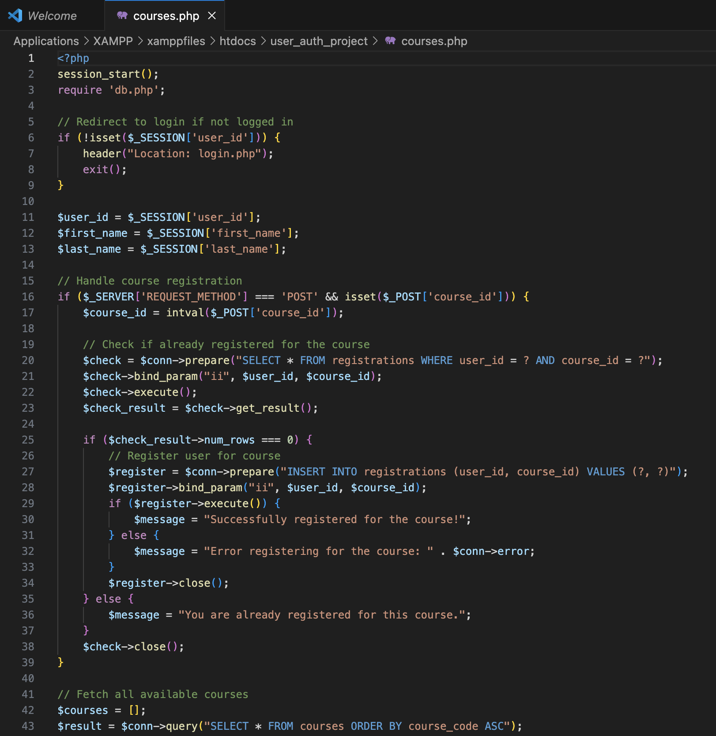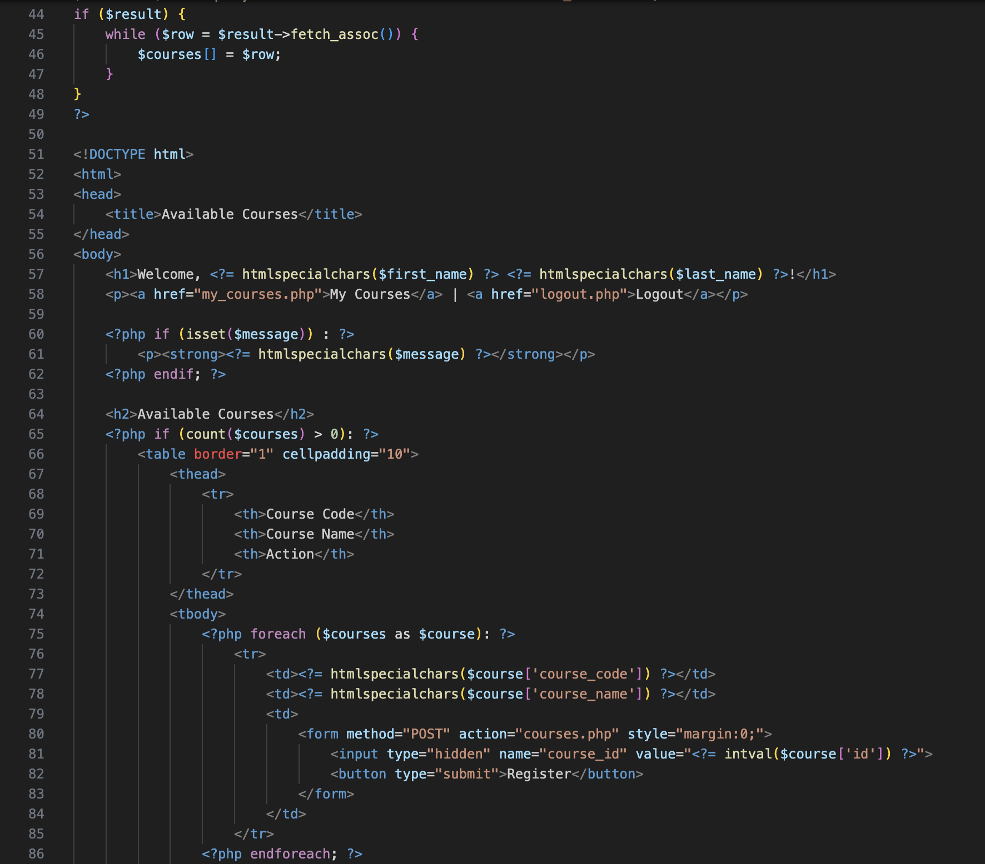

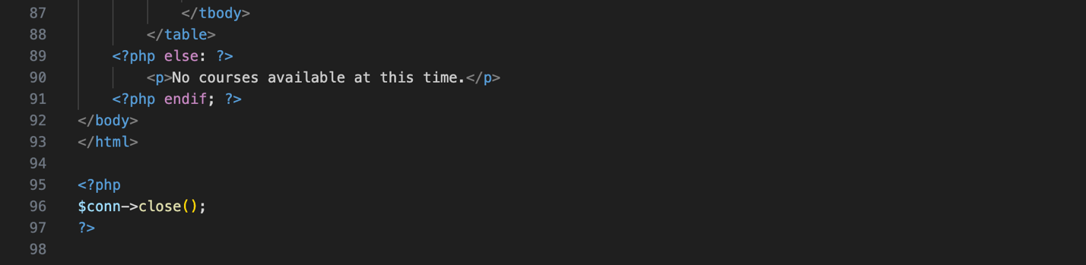

My_courses.php:  
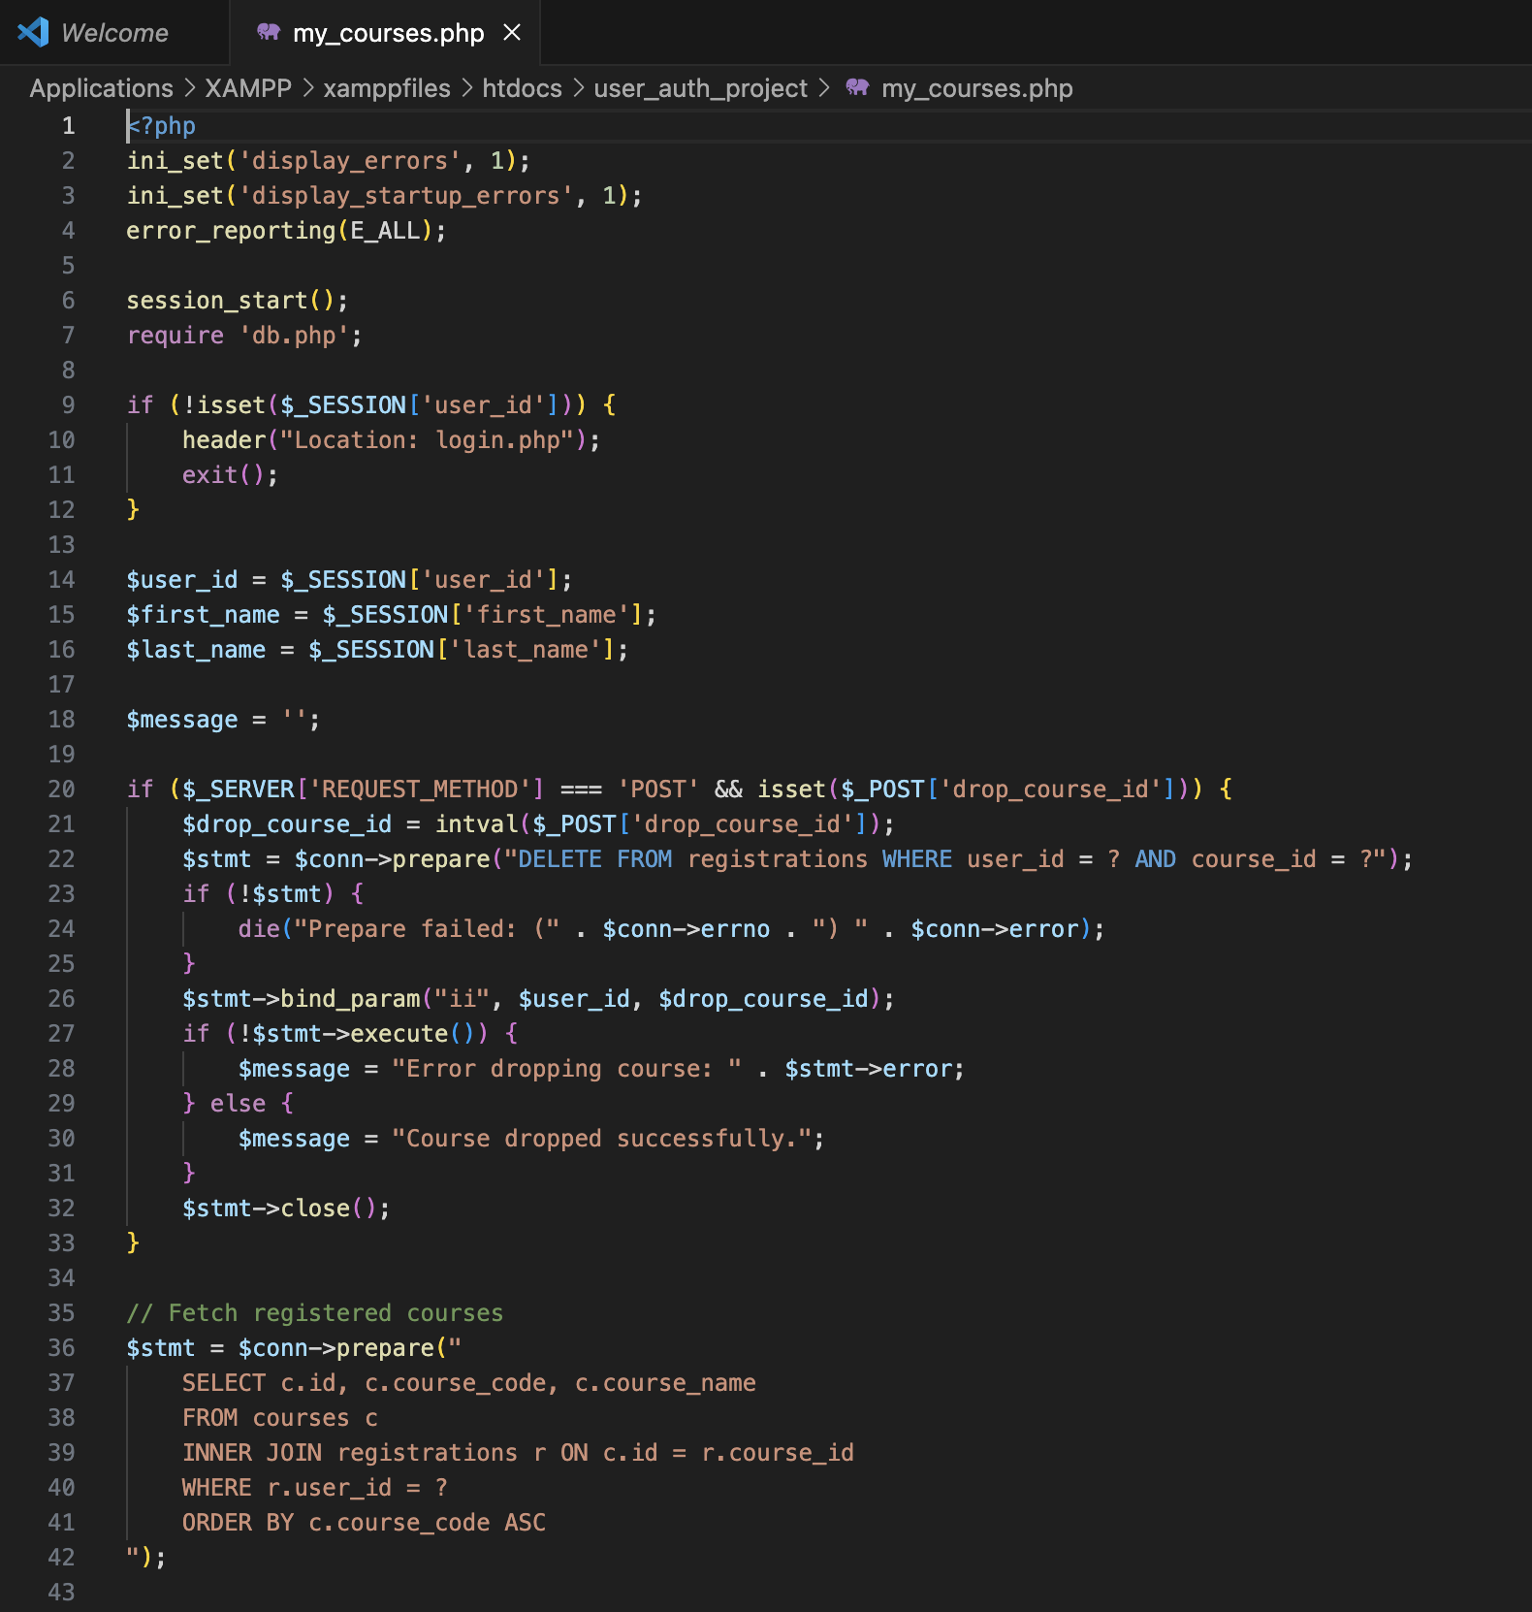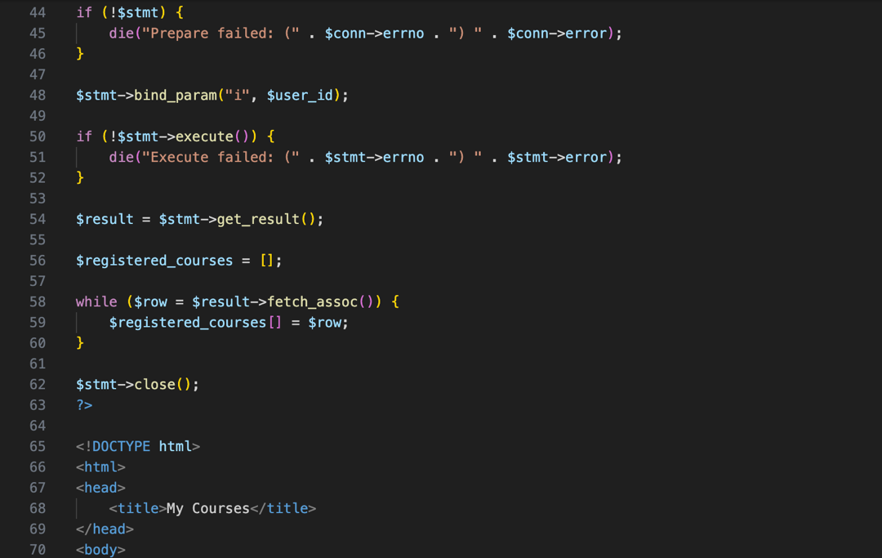

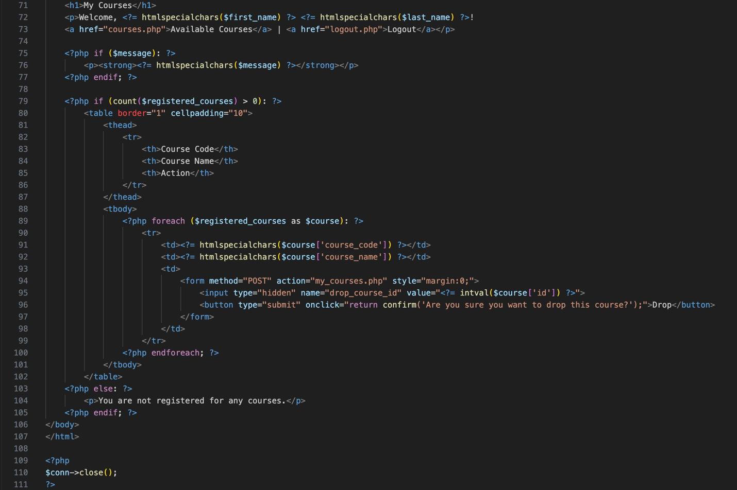

Delete_course.php

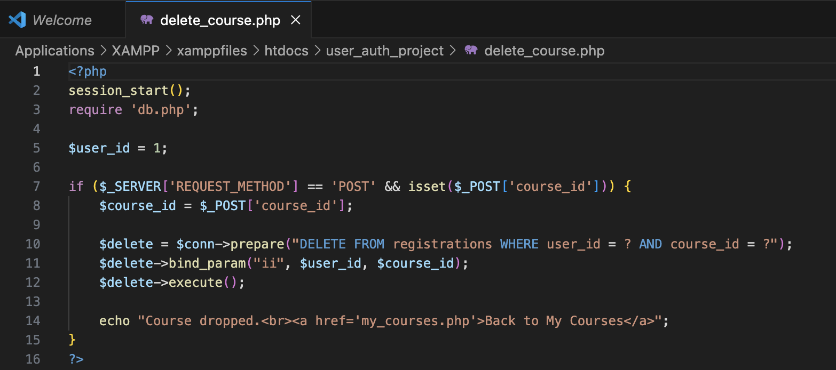

Logout.php:

